Get BG Wise Initialization VM Report

# Overview

It provides the initialization status of a VM possessed by a BG i.e. it tells if a VM has been initialized or uninitialized or it is not applicable for initialization (in case the VM is blank or created as a custom template). The final Report shows status of all the VMs Possessed by a Business Group.

# Goal

It is prepared to get the initialization status of a VM as there were no mode existing to know if applicable, a VM has been initialized or not.

# Solution /Logic design

If NO end

Is request_org ==

bg

Get request Name, request organization,requested by,request State

vcacCAFEHsot

findRequests(vcacCAFEHost,“Initialize VM”)

IF YES

Split request Name with “-” and for each part of the VM NAME concatenate them with “-”

If request state == ‘successful’

IF NO end

Put vm name and requester in map ‘initializedVM’

Fetch VM details of a BG through

Action “getVMs”

Put vms of the bg in map ‘bgVMs’ along with the owner

If vms in bgVMs exists in intializedVMs

# if yes if no

vmState =“Initialized”

vmState = “Uninitialized”

If VM Blueprint has phrases ‘match’ or ‘blank’ in its name

IF NO

vmState = ‘Uninitialized’

IF YES

vmState = ‘Not Applicable’

Push required data to array and write it in a file through action ’WriteDataToFile’ and send with the mail through workflow ’send Mail’

end

# VM properties

* VM Name – Name of the virtual Machine.
* Initialization status – It tells if a VM is initialized, uninitialized or not applicable for initialization.
* VM IP Address - IP of a virtual Machine.
* Operating System – OS mount on VM.
* Owner – the one who owned/Created a VM.

Dependencies

# Related Actions

* WriteDataToTheFile – It writes the requested data to the provided file.
* ValidateEmail – It validates the mail Address.
* ListBG – it lists out all the business group existing on VRA.
* getVMs - It is a function which provides VMs and its data related to a Particular BG.

# Related WorkFlows

* Send Mail – It attaches the file with the mail and send it to the requester.

# Related Configuration elements

* fromName – Sender’s name who is sending the mail
* fromAddress – Sender’s email address
* vCACCAFEHost – host through which VRO connect with VRA to fetch the required data.
* vCACHost – host through which VRO connect with Iaas services of VRA.
* SmtpHost – with which one will be able to connect to the server to send the mail.
* CcAddress – it includes other member’s mail address to whom requester wants to send the mail.
* smtpPort - with which one will be able to connect to the server to send the mail.

# Attributes

These are the attributes used in the workflow which are self-explanatory from the picture.

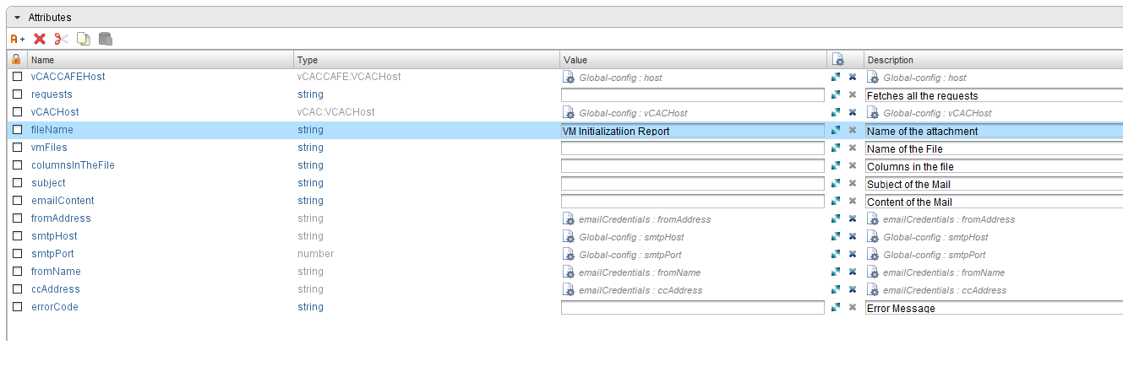

# Inputs

These are the inputs used in the workflow which are self-explanatory from the picture.

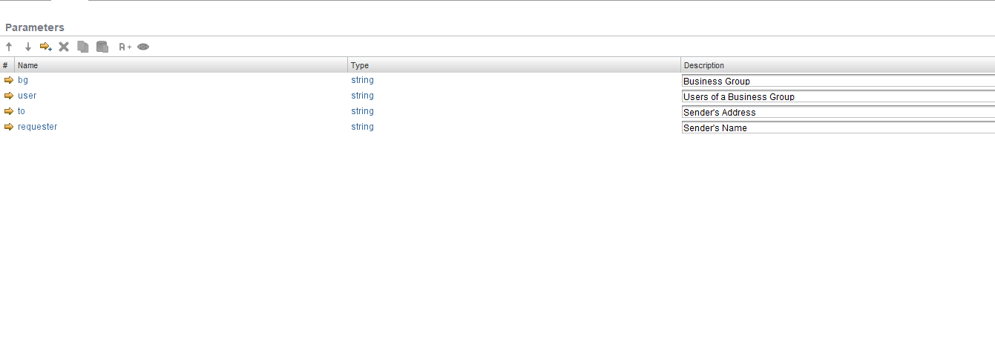

# Future scope

* The initialization status can be provided as a custom Property of any VM so that every VM’s status can be known from the VRA itself rather than going to the tedious procedure of reading a report.